**ADVANCE MICROPROCESSOR PROJECT**



*DHARAMSINH DESAI UNIVERSITY*

*FACULTY OF TECHNOLOGY*

**PROJECT NAME : FILE MANAGER**

**PREPARED BY : PISHANG UJENIYA (IT-100)**

**GUIDED BY : PROF. SIDDHI JOSHI**

# **DESCRIPTION**

My project aims to implement File Manager using Buttons as Graphical User Interface

It would be consisting of following functionalities of File Management.

1. Create a File
2. View a File
3. Copy a File
4. Rename a File
5. Delete a File
6. Create a Directory
7. Remove a Directory
8. Change a Directory
9. List all in a Directory
10. Buttons Action for Above all functions

To perform the above mentioned tasks I have used mainly three Bios Interrupts, INT 10h, INT 33h, INT 21h

**Basic usage of Interrupts**

**INT 10h** is used for Screen Manipulation.

**INT 33h** is used for Mouse Interrupts.

**INT 21h** is used for File Handling and echo text.

# **GRAPHICS MODE**

MOV AX, 12H *; set graphics mode*

INT 10H

# **TEXT MODE**

MOV AL, 03H *; set text mode*

MOV AH, 00H

INT 10H

# **CREATING A BUTTON RECTANGLE**

MOV CX,21D *; screen column*

MOV DX,210D *; screen line*

MOV AL,09H *; colour of pixel*

MOV AH,0CH *; print pixel*

SNA1:INT 10H

INC CX

CMP CX,155D

JNE SNA1

INC DX

MOV CX,21D

CMP DX,259D

JNE SNA1

# **DISPLAY STRING IN BUTTON**

MOV AL,01H *; write mode*

MOV BH,0H *; page number*

MOV BL,04H *; text color change*

MOV CX,04D *; no of characters in string*

MOV DL,7D *; column start*

MOV DH,14D *; row start*

MOV BP,OFFSET S1

MOV AH,13H *; print string*

INT 10H *; print string interrupt*

# **MOUSE INITIALISATION**

AGAIN: MOV AX,0000H

INT 33H

CMP AX,0000H *; ax=0 mouse driver not installed*

JE AGAIN

MOV AX, 0001H

INT 33H

# **MOUSE CLICK SCANNING**

CHECK4:

MOV AX,0003H

INT 33H

CMP BX,1H

JNE CHECK4

CMP CX,486D *; greater than or equal 486d we want*

JC CHECK3 *; to next button*

CMP CX,620D *; less than 620d*

JNC CHECK4

CMP DX,210D *; greater than or equal 210d we want*

JC CHECK1 *; to first button*

CMP DX,260D *; less than 260d*

JNC CHECK1 *; to first button*

CALL BT4 *; action if button pressed*

# **CREATING A FILE**

CREATE:

CALL SIMPLE

LEA DX, MSG2  *; module for creating a file*

CALL DISP1

CALL READ1 *; read name of file to be*

LEA DX, BUFFER1[2] *; created*

MOV CX, 0

MOV AH, 3CH *; create the file*

INT 21H

PUSH AX *; push file handle onto stack.*

LEA DX, MSG28 *; ask if data is to*

CALL DISP1 *; be input*

CALL READCH *; read choice*

AND AL, 0FH

CMP AL, 9  *; if choice = 'y' or 'y'*

JNZ NO

LEA DX, MSG29

CALL DISP1

POP BX *; retrieve file handle from stack.*

MOV BUFFER1[1], 0

WRITE : CALL READCH  *; read data character by character.*

MOV BUFFER1[0], AL

CMP BUFFER1[0], 27 *; check if character is 'esc'(stop).*

JZ NO

CMP BUFFER1[0], 0DH

JNE NEOL

LEA DX, MSG26

CALL DISP1

MOV SI, DX

MOV BYTE PTR DS:[SI + 2], 0

MOV CX, 3

JMP COM

NEOL : MOV CX, 1

LEA DX, BUFFER1[0]

COM : MOV AH, 40H *; write to the file*

INT 21H

MOV BYTE PTR DS:[SI + 2], '$'

JMP WRITE

ENDING: JMP ENDINGII

NO : LEA DX, MSG16 *; creation successful*

CALL DISP1

CALL READCH

JMP BEGIN

# **DELETING A FILE**

DELETE:

CALL SIMPLE

LEA DX, MSG3 *; module for deleting a file*

CALL DISP1

CALL READ1 *; read name of file to be deleted*

LEA DX, BUFFER1[2]

MOV AH, 41H *; delete the file*

INT 21H

CMP AX, 2 *; error if file not found*

JNZ ERR2

LEA DX, MSG14

CALL DISP1

JMP ENDD

ERR2 : CMP AX, 5 *; error if access denied*

JNZ DONE

LEA DX, MSG15

CALL DISP1

JMP ENDD

DONE : LEA DX, MSG17 *; delete successful*

CALL DISP1

ENDD : CALL READCH

JMP BEGIN

# **RENAME A FILE**

RENAME:

CALL SIMPLE

LEA DX, MSG4 *; module for renaming a file*

CALL DISP1

CALL READ1 *; read name of file to be renamed*

LEA DX, MSG5

CALL DISP1

CALL READ2 *; read new name of file*

PUSH DS

POP ES

LEA DX, BUFFER1[2]

LEA DI, BUFFER2[2]

MOV AH, 56H *; rename file*

INT 21H

CMP AX, 2 *; error if file not found*

JNZ ERR3

LEA DX, MSG14

CALL DISP1

JMP ENDE

ERR3 : CMP AX, 3 *; error if path not found*

JNZ ERR4

LEA DX, MSG14

CALL DISP1

JMP ENDE

ERR4 : CMP AX, 5 *; error if access denied*

JNZ REN

LEA DX, MSG15

CALL DISP1

JMP ENDE

REN : LEA DX, MSG18 *; rename successful*

CALL DISP1

ENDE : CALL READCH

JMP BEGIN

# **VIEW – EDIT A FILE**

LEA DX, MSG30 *; module to view the*

CALL DISP1  *; contents of a file*

CALL READ1 *; read name of file*

LEA DX, MSG26

CALL DISP1

CALL DISP1

LEA DX, BUFFER1[2] *; open the file*

MOV AX, 3D02H

INT 21H

MOV BUFFER2[0], 0

CMP AX, 2  *; error if file not found*

JNZ V_ERR

LEA DX, MSG14

CALL DISP1

JMP ENDV

V_ERR : CMP AX, 3 *; error if path not found*

JNZ CONT2

;JNZ PUSH

LEA DX, MSG21

CALL DISP1

JMP ENDV

CONT2 : MOV BX, AX

PUSH AX

MOV CX, 1

LEA DX, BUFFER1

MOV AH, 3FH *; read the file*

INT 21H

CMP AX, 0 *; stop if end-of-file*

JZ PUSH

JNZ SHOW2

ENDINGI: JMP ENDINGS

SHOW2 : MOV BUFFER1[1], '$'

LEA DX, BUFFER1

CALL DISP1

POP AX

JMP CONT2

CMP BUFFER1[0], 0DH

; JNZ SHOW

INC BUFFER2[0]

CMP BUFFER2[0], 23 *; check if end of page*

JNZ SHOW1TEMP

SHOW1TEMP: JMP SHOW1

;JNZ PUSH

LEA DX, MSG27

CALL DISP1

CALL READCH

MOV BUFFER2[0], 0

LEA DX, MSG26

CALL DISP1

PUSH: MOV AH,02

MOV AL,0

MOV CX,0

MOV DX,10

INT 21

;INT 21H

;PUSH AX *; push file handle onto stack.*

LEA DX, MSG28 *; ask if data is to*

CALL DISP1 *; be input*

CALL READCH *; read choice*

AND AL, 0FH

CMP AL, 9 *; if choice = 'y' or 'y'*

JNZ NO1

LEA DX, MSG29

CALL DISP1

POP BX *; retrieve file handle from stack.*

MOV BUFFER1[1], 0

WRITE1 : CALL READCH *; read data character by character.*

MOV BUFFER1[0], AL

CMP BUFFER1[0], 27 *; check if character is 'esc'(stop).*

JZ NO1

CMP BUFFER1[0], 0DH

JNE NEOL1

LEA DX, MSG26

CALL DISP1

MOV SI, DX

MOV BYTE PTR DS:[SI + 2], 0

MOV CX, 3

JMP COM1

NEOL1 : MOV CX, 1

LEA DX, BUFFER1[0]

COM1: MOV AH, 40H *; write to the file*

INT 21H

MOV BYTE PTR DS:[SI + 2], '$'

JMP WRITE1

NO1 : LEA DX, MSG16  *; creation successful*

CALL DISP1

CALL READCH

JMP BEGIN

;JMP CR_FILE

SHOW1 : MOV BUFFER1[1], '$'

LEA DX, BUFFER1

CALL DISP1

POP AX

JMP CONT2

ENDV : CALL READCH

JMP BEGIN

# **COPY A FILE**

COPY:

CALL SIMPLE

LEA DX, MSG6 *; module for copying a file*

CALL DISP1 *; read name of file to*

CALL READ1  *; to be copied*

MOV CX, BX

LEA DX, MSG7

CALL DISP1

CALL READ2 *; read path of destination*

MOV BUFFER2[BX], '\' *; directory*

INC BX

MOV AX, 2

CP : MOV SI, AX  *; concatenating path and filename*

MOV DL, BUFFER1[SI]

MOV BUFFER2[BX], DL

INC BX

INC AL

CMP CX, AX

JNE CP

MOV CX, 0

LEA DX, BUFFER2[2] *; create the file in*

MOV AH, 3CH *; destination directory*

INT 21H

CMP AX, 3 *; display error message*

JNZ CONT *; if path not found*

LEA DX, MSG21

CALL DISP1

JMP COPY *; on error read data again*

CONT : PUSH AX

LEA DX, BUFFER1[2] *; open source file*

MOV AX, 3D00H

INT 21H

PUSH AX

RD : POP BX

LEA DX, BUFFER1

MOV CX, 80H  *; read source file*

MOV AH, 3FH

INT 21H

CMP AX, 0 *; check if entire file*

JZ FIN  *; has been read*

MOV CX, BX

POP BX

PUSH BX

PUSH CX

MOV CX, AX

LEA DX, BUFFER1 *; write into new file to*

MOV AH, 40H *; complete copy task*

INT 21H

JMP RD *; read file further*

FIN : LEA DX, MSG25 *; copy successful*

CALL DISP1

CALL READCH

JMP BEGIN

# **CREATING A DIRECTORY**

CRDIR :

CALL SIMPLE

LEA DX, MSG8 *; module for creating*

CALL DISP1 *; a directory*

CALL READ1 *; read name of directory*

LEA DX, BUFFER1[2] *; to be created*

MOV AH, 39H *; create directory*

INT 21H

CMP AX, 3 *; error if path not found*

JNZ ERR5

LEA DX, MSG21

CALL DISP1

JMP ENDF

ERR5 : CMP AX, 5 *; error if access denied*

JNZ DONE1

LEA DX, MSG15

CALL DISP1

JMP ENDF

DONE1 : LEA DX, MSG19  *; creation successful*

CALL DISP1

ENDF : CALL READCH

JMP BEGIN

# **REMOVING A DIRECTORY**

REDIR :

CALL SIMPLE

LEA DX, MSG9 *; module for removing directory*

CALL DISP1

CALL READ1 *; read name of directory to*

LEA DX, BUFFER1[2]  *; be removed*

MOV AH, 3AH  *; remove directory*

INT 21H

CMP AX, 3 *; error if path not found*

JNZ ERR6

LEA DX, MSG21

CALL DISP1

JMP ENDG

ERR6 : CMP AX, 5 *; error if access denied*

JNZ DONE2

LEA DX, MSG15

CALL DISP1

JMP ENDG

DONE2 : LEA DX, MSG20 *; deletion successful*

CALL DISP1

ENDG : CALL READCH

JMP BEGIN

# **CHANGING A DIRECTORY**

CHDIR :

CALL SIMPLE

LEA DX, MSG10 *; module for changing directory*

CALL DISP1

CALL READ1 *; read name of directory to*

LEA DX, BUFFER1[2] *; be changed to*

MOV AH, 3BH *; change directory*

INT 21H

CMP AX, 3 *; error if path not found*

JNZ DONE3

LEA DX, MSG21

CALL DISP1

JMP ENDH

DONE3 : LEA DX, MSG22 *; change successful*

CALL DISP1

ENDH : CALL READCH

JMP BEGIN

CH_DRV :LEA DX, MSG13 *; module for changing drive*

CALL DISP1

CALL READ1 *; read name of drive*

MOV DL, 0

CMP BUFFER1[2], 'A'

JZ FLOPPY

CMP BUFFER1[2], 'C'

MOV DL, 2

FLOPPY :MOV AH, 0EH  *; change drive*

INT 21H

LEA DX, MSG23 *; change successful*

CALL DISP1

CALL READCH

JMP BEGIN

# **LISTING A DIRECTORY**

LISTING:

CALL SIMPLE

MOV AX, 3H *; module for displaying*

INT 10H *; contents of directory*

LEA DX, MSG24

MOV CX, 0

MOV AH, 4EH  *; get first file*

INT 21H *; in directory*

CMP AX, 18 *; check if no files*

JNZ LIST  *; in directory*

LEA DX, MSG14 *; display message*

CALL DISP1 *; 'file not found'*

CALL READCH

JMP BEGIN

LIST : MOV AH, 2FH *; get dta address*

INT 21H

MOV BYTE PTR ES:[BX + 42], 0

ADD BX, 1EH

MOV BUFFER1[0], 0

CHAR : MOV DL, BYTE PTR ES:[BX] *; get character of*

INC BX *; filename from dta*

INC BUFFER1[0]

CMP DL, '.' *; check if extension*

JNZ CONT3 *; is starting*

CONT4 : LEA DX, MSG31

CALL DISP1

INC BUFFER1[0]

CMP BUFFER1[0], 0BH *; check for end of filename*

JNE CONT4 *; buffer - 13 characters*

JMP CHAR

CONT3 : MOV AH, 02H *; display character*

INT 21H *; of filename*

CMP DL, 0 *; check for end*

JNE CHAR *; of file name*

LEA DX, MSG26

CALL DISP1

INC CX

CMP CX, 23 *; check for end of page*

JNE CONT1

LEA DX, MSG27

CALL DISP1

CALL READCH

MOV CX, 0

LEA DX, MSG26

CALL DISP1

CONT1 : MOV AH, 4FH *; get next file*

INT 21H

JNC LIST

LEA DX, MSG27

CALL DISP1

CALL READCH

JMP BEGIN1

# **SCREENSHOTS**

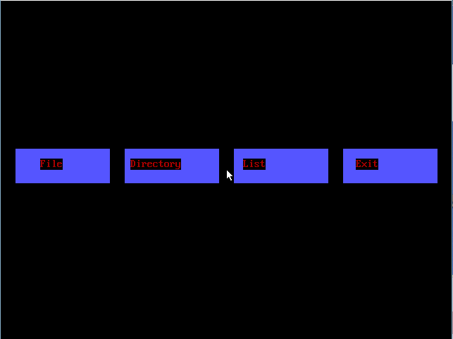

Screenshot 1 Homepage

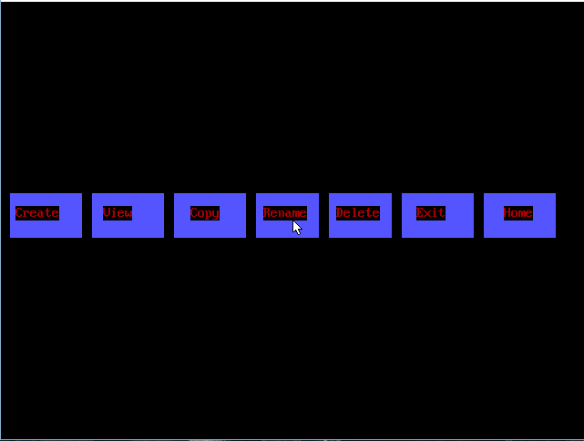

Screenshot 2 FileButtonClicked

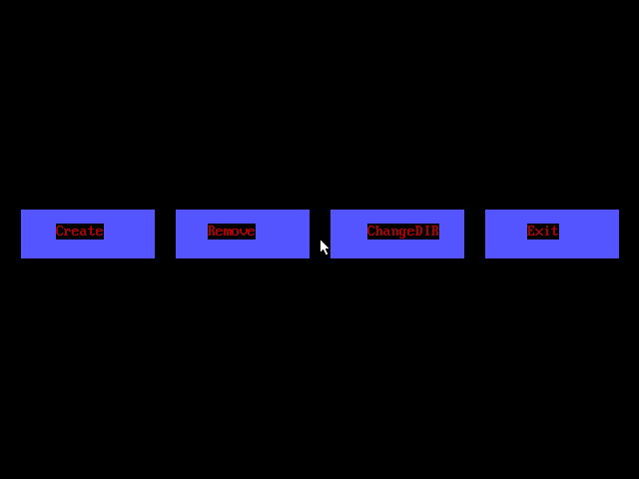

Screenshot 3 DirectoryButtonClicked

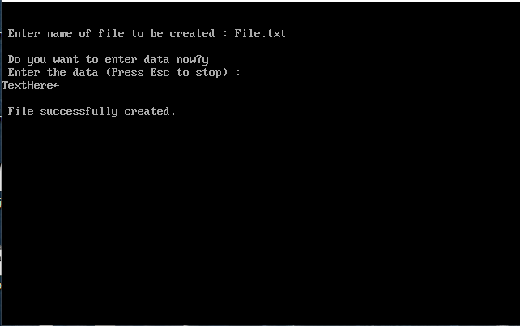

Screenshot 4 CreateFile

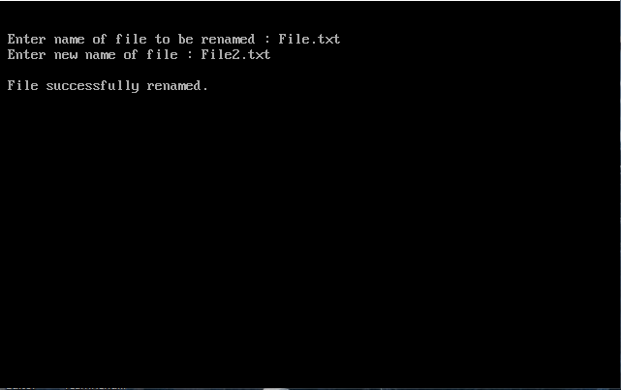

Screenshot 5 RenameFile

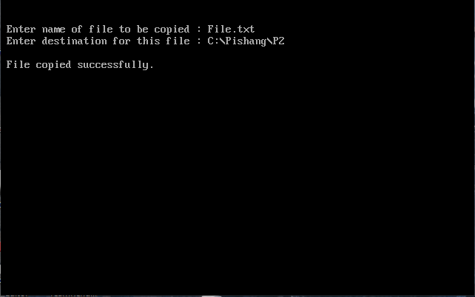

Screenshot 6 CopyFile

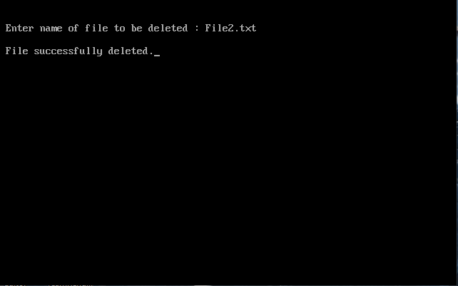

Screenshot 7 DeleteFile

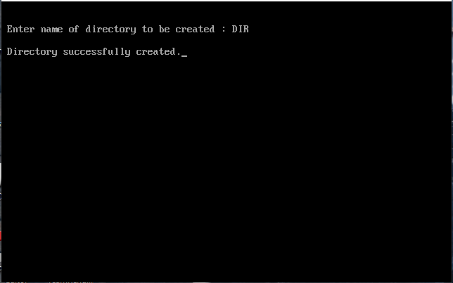

Screenshot 8 CreateDirectory

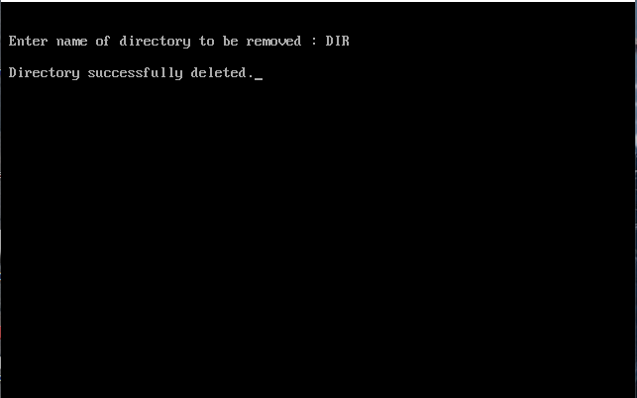

Screenshot 9 RemoveDirectory

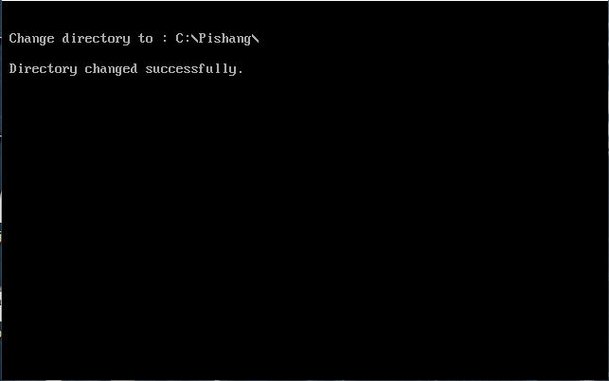

Screenshot 10 ChangeDirectory

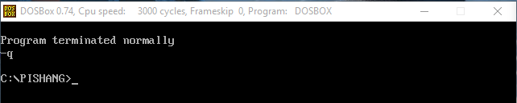

Screenshot 11 DirectoryChanged-at-prompt-checked-after-exiting-program

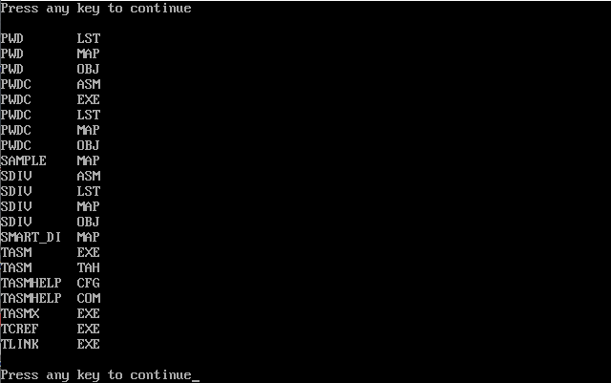

Screenshot 12 ListingDirectory